Installing Rapport
Contents
1 Introduction 1
1.1 License 1
2 PHP for windows 2
2.1 downloading 2
2.2 Installing 2
2.2.1 shortcuts 2
2.3 Configuring 2
2.3.1 Start uniserver 3
2.3.2 Create a SSL certificate 3
2.3.3 Change the SSL port 3
2.3.4 Select the PHP version 3
2.4 Virtual host 4
2.4.1 Create a folder to store the code for rapport 4
2.4.2 Create a vhost 4
3 Site pages 5
3.1 rapport 5
3.2 phpinc dependencies 5
3.3 jsinc dependencies 5
3.4 secrets 5
3.5 add a redirect 5
4 Start the server 7
4.1 Add a link to https page 7
4.2 Start the web server 7

Introduction
Rapport provides at-a-glance information about your AppDynamics™. It is an open source, lightweight, coded entirely in PHP and JavaScript, web application.
This document describes how to install Rapport on your own windows desktop. However it can be deployed anywhere where you can run a PHP server.

License
Rapport is copyrighted by sunil at chickenkatsu.co.uk and licensed under the terms of the Creative Commons Attribution-NonCommercial-NoDerivatives 4.0 International License.

PHP for windows

downloading
I use the lightweight Uniform Zero XIV LAMP distribution - self extracting zip files can be downloaded at sourceforge
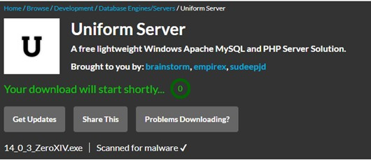
Always use a virus checker to confirm that downloaded files are safe.

Installing
The downloaded file is a self-extracting zip file that runs as a portable application (ie it doesn’t require any installation, just unpack and go) . You can extract it yourself into the directory that you want uniserver to run from.
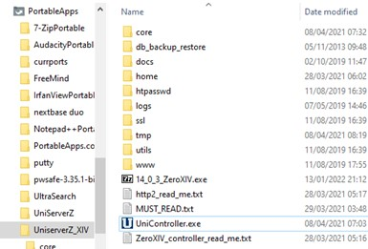
Please also download Visual C++ Redistributable for Visual Studio 2019 as noted in the file MUST_READ.txt from
It can be downloaded from:
https://docs.microsoft.com/en-US/cpp/windows/latest-supported-vc-redist?view=msvc-170#visual-studio-2015-2017-2019-and-2022
Select: vc_redist.x86.exe

shortcuts
From now on we will use the following shortcuts in this document
$UNISERVER as the location of where uniserver is installed
$APACHE as a shortcut for $UNISERVER/core/apache2

Configuring
Uniform zero is designed to run with minimal configuration. There are some things we need to do from the uniserver console.
Optional: In my version of uniserver I disable MySQL support by deleting the folder $UNISERVER/core/mysql

Start uniserver
Start the console: by running $UNISERVER/UniController.exe (or in my case I start it from portable Apps)
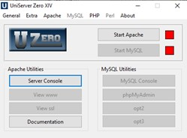

Create an SSL certificate
Rapport runs on the cloud as https, even the on the development environment you must run https.
Luckily this is super easy on uniserver using the server cert and key generator
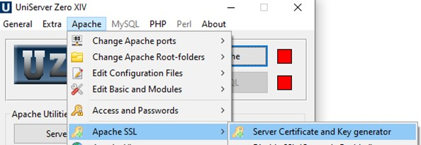

If the apache SSL option is disabled stop Apache first to enable the option.

Change the SSL port
Port 443 is usually privileged – best to change the port to 8443
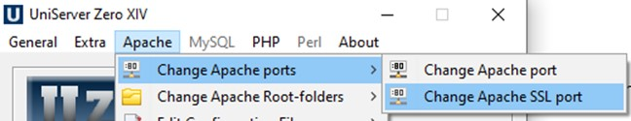

Select the PHP version
Without this when you run apache, PHP wont run
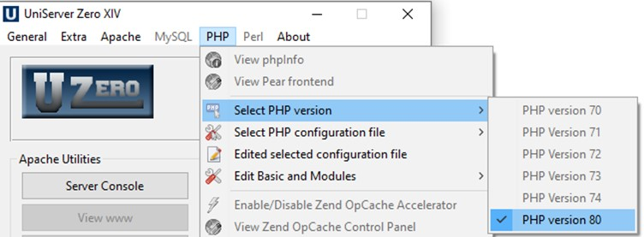

Virtual host
Its best to separate your development into a virtual host to keep the project self-contained and log files separate

Create a folder to store the code for rapport
We will refer to this below as $RAPPORT
It is preferable to create an environment variable called RAPPORT

Create a vhost
You can use the uniserver zero ui to create an ssl virtual host
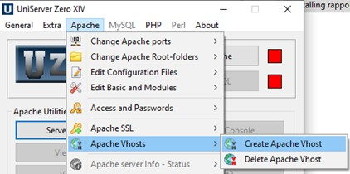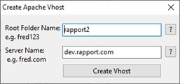

Create hosts entry for your virtual host
Eg for https://dev.rapport:8443/
In this case edit the hosts file at
%windir%\System32\drivers\etc\hosts
And add the line
127.0.0.1 dev.rapport

Create a ssl virtual host
- Edit the file $APACHE/conf/extra/httpd-ssl.conf
- Copy the vhost section
<VirtualHost _default_:${AP_SSL_PORT}>
…
</VirtualHost>
- Paste the vhost section changing the label to dev.rapport:${AP_SSL_PORT}
- In the new dev.rapport vhost section change the following
<VirtualHost dev.rapport:${AP_SSL_PORT}>
ErrorLog "${US_ROOTF}/core/apache2/logs/rapport_error_ssl.log"
TransferLog "${US_ROOTF}/core/apache2/logs/rapport_access_ssl.log"
DocumentRoot "$RAPPORT"
ServerName "dev.rapport"
Options Indexes
<Directory "$RAPPORT">

Do an apache syntax check
Just in case an error was introduced
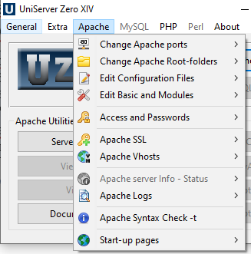

Site pages
The site needs a number of subdirectories:
- appdinc – php classes to interrogate the AppDynamics ®™ APIs
- phpinc – useful PHP functions
- jsinc – useful javascript functions
- rapport – the rapport web application
you will also need something to be able to clone github repos. I recommend using github desktop for developing. But if you just want to download just use a web browser

rapport
Files/folder | source
$RAPPORT/app/ | https://github.com/open768/rapport

phpinc dependencies
File/folder | source
$RAPPORT/phpinc/ | https://github.com/open768/phpinc/
$RAPPORT/phpinc/appd/ | https://github.com/open768/appdinc
$RAPPORT/phpinc/extra/php-openssl-crypt/cryptor.php | https://github.com/ioncube/php-openssl-cryptor/tree/master/src

jsinc dependencies
File/folder | source
$RAPPORT/jsinc/ | https://github.com/open768/jsinc
$RAPPORT/jsinc/extra/jquery/jquery-3.2.1.min.js | https://jquery.com/download/
$RAPPORT/jsinc/extra/jquery-ui/jquery-ui.min.js | https://jqueryui.com/download/
$RAPPORT/jsinc/extra/tablesorter/jquery.tablesorter.min.js | https://github.com/christianbach/tablesorter
$RAPPORT/jsinc/extra/jquery-inview/jquery.inview.min.js | https://github.com/protonet/jquery.inview
$RAPPORT/jsinc/extra/jquery-visible/jquery.visible.min.js | https://github.com/customd/jquery-visible
$RAPPORT/jsinc/extra/jquery-spinner/g-spinner.min.js | https://github.com/ceckenrode/g-spinner/tree/master/src
$RAPPORT/jsinc/extra/jquery-qtip/jquery.qtip.min.js | https://github.com/salesagility/SuiteCRM/tree/master/include/javascript/qtip
$RAPPORT/jsinc/extra/jquery-mdl-dialog/mdl-jquery-modal-dialog.js | https://github.com/oRRs/mdl-jquery-modal-dialog/blob/master
$RAPPORT/jsinc/extra/jquery-flowtype/flowtype.js | https://github.com/simplefocus/FlowType.JS/
$RAPPORT/jsinc/extra/bean/bean.js | https://github.com/fat/bean

secrets
- make a copy of the file $RAPPORT/inc/secret-example.php as $RAPPORT/inc/secret.php
- edit $RAPPORT/inc/secret.php and provide your secrets as needed.

add a redirect
WORK in progress
create an .htaccess file in $RAPPORT so that it redirects to the rapport app
DirectoryIndex index.php
RewriteEngine On
RewriteRule /index.php /app/

Start the server

Add a link to https page
At startup Uniserver shows the pages served by http server, not by the https server. So go and edit $UNISERVER/www/index.php to add the https served pages. Example below
<h2>Server links</h2>
…
<p><a href="https://dev.rappport:8443/">Rapport</a>

Start the web server
This couldn’t be simpler – just click the start apache button
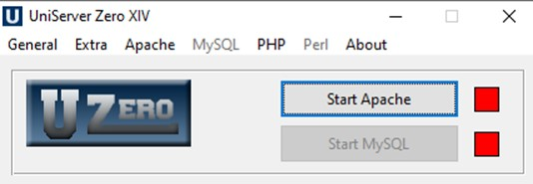
This will launch a web browser
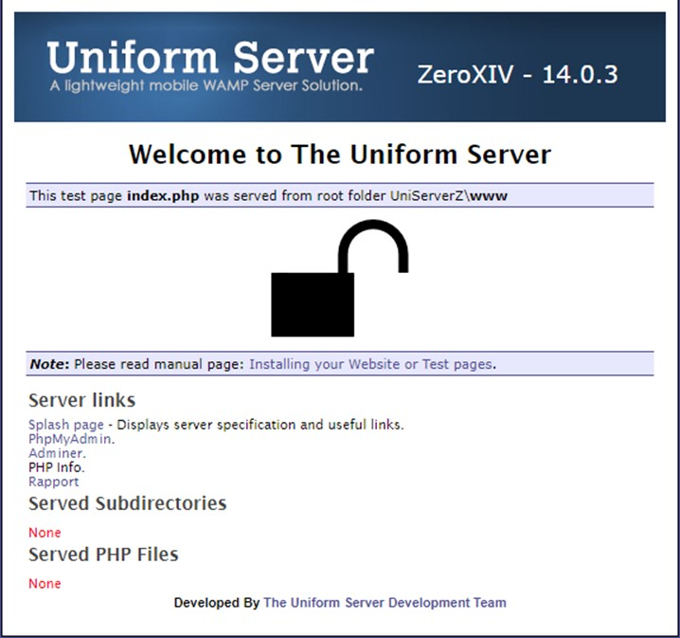
We’re not quite ready to click the rapport button yet

